[INSERT LOCATION] BACKS CALL FOR ‘SPECIAL SUPPORT’ MEASURES FOR RETAIL, HOSPITALITY AND LEISURE BUSINESSES
- [Insert bullet on how many businesses represented]
- [Insert regionalised pressure/pain point]
- [Insert regionalised Tier issue]
[Tailored introduction specific to the region/ linking backing for the ‘special support’ outlined in the Bounce Back Better campaign.]

From Wednesday 2 December, England will fall back into a Tiered system, placing irrevocable pressure on hospitality businesses but also those in retail and leisure sectors. UKHospitality has already warned that the new Tier 3 system will result in 94% of hospitality businesses becoming unviable by March 2021. In Tier 2 it is 75% and even at Tier 1 25%.

We agree that sector specific measures require sector specific support, and this manifesto outlines a range of packages which will provide a vital lifeline for hospitality, retail and leisure businesses alike.

The manifesto follows intense and thorough talks with businesses, Business Improvement Districts [BIDs], Local Authorities, destinations and industry bodies to provide options of support to help the UK economy ‘Bounce Back Better’.

Rishi Sunak, Chancellor of the Exchequer [18 March 2020], ‘We will support jobs. We will support incomes. We will support businesses. We will help you protect loved ones. We will do whatever it takes.”

Matthew Sims, Founder ‘Bounce Back Better’ campaign and CEO Croydon Business Improvement District says, “The government has provided assurances it will do whatever it takes to support British businesses and help them to bounce back from the coronavirus pandemic. Businesses are approaching a cliff edge and need the government to provide a parachute in sector specific measures to stave off mass closure and job losses. Now, more than ever, we need the Chancellor to stand by his promise to do whatever it takes.”

FOUR ESSENTIAL ASKS IN THE ‘BOUNCE BACK BETTER’ MANIFESTO”:

1.ONE-OFF GRANT FOR RETAIL, LEISURE & HOSPITALITY BUSINESSES

Local Authorities lack the administrative and payments infrastructure required to facilitate monthly financial support model proposed by government for eligible businesses in Tier 2 and Tier 3 – many businesses are receiving funds too late, or worse not at all.

We ask Government to provide a one-off ‘Bounce Back’ grant of up to £15,000 for retail, hospitality and leisure businesses in Tier 2 and Tier 3 across England and Wales with a rateable value of up to and including £150,000. This would support 137,000 businesses vital funds delivered in a manner Local Authorities are equipped to distribute at a total maximum cost of £2.05bn.

2. PAUSE NATIONAL INSURANCE EMPLOYER CONTRIBUTIONS FOR FURLOUGHED EMPLOYEES

For the furlough scheme investment to date of £47m to be fully effective, business support must reflect short and long term challenges.

While employees receive 80% of their salary through the extension of the furlough scheme, businesses are still paying out for National Insurance, placing greater strain on survival. At an average wage of £9.50 per hour, working 7.5 hours per day, 5 days a week, the National Insurance cost to a business in hospitality with 10 staff is £491.60 per week. Every month, on top of all the other costs, businesses will be paying out £1,966.50 – nearly two thirds of the upper limit of funding provided by the Government currently.

We ask Government to remove the burden of National Insurance from employers whose staff are on furlough, saving the average business £2,000 per month until 31st March 2021.

3. EXTENSION OF 100% BUSINESS RATES HOLIDAY FOR 2021/22

The ‘payment holiday’ for retail, hospitality and leisure businesses with a rateable value less than £51,000 earlier this year was an extraordinary and critical measure saving each business up to £25,000, a total tax cut worth over £1bn.

We ask Government to extend the 100% business rates holiday into 2021/2022 for businesses in the retail, hospitality and leisure sector. Every pound saved is a pound to help businesses stay trading and retain staff.

4. EXTENSION OF VAT REDUCTION SCHEME

The cut in VAT from 20% to 5% is a major boost for the hospitality sector enabling businesses to pass on a £4.1 billion saving onto consumers. With a vaccine becoming a reality in the coming months, our Bed and Breakfasts, hotels and restaurants could be a vital catalyst to local economic recovery.

Research by CGA for UKHospitality, the British Beer and Pub Association and the British Institute of Inn keeping found support on VAT and business rates are top of hospitality's essential business support needs. Four in 10 affected businesses have stated that the government needs to extend its VAT cut to remain viable.

We ask Government to extend the VAT reduction from 1 April 2021 up to and including 31 March 2022.

Bill Addy, Chair of the BIFD Foundation and CEO of Liverpool BID Company said: “The government has the chance to act now and lessen lasting damage to economic growth and jobs. The UK’s economy recovery rests on local businesses continuing to trade and generate employment opportunities. This manifesto asks the government to extend existing measures and introduce a one-off funding injection that together will stem the bleeding out businesses are facing."

Melanie Brown, The Laundry Restaurant, Brixton, “The government appears to be out of touch with the costs associated with running a business. Our costs far outweigh the £3k grant offered under the current scheme and more is needed to support businesses like The Laundry Restaurant. While we and our staff appreciate the furlough scheme, the grant funding will not even cover the costs we have for National Insurance and pension contributions let alone rent, supplier costs and utilities. The government needs to do far more to support businesses in hospitality with grants that go some way to ease the pressure we are under. Without it, far more businesses will go to the wall and with them, the employees the Government is working so hard to protect.”

ENDS

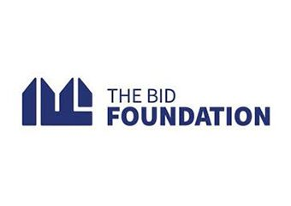
Supportive partners:
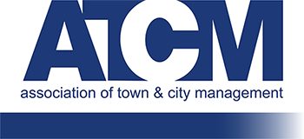
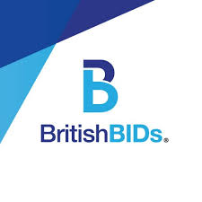

Support the campaign

Visit www.raisethebarcampaign.com to download our assets

To get involved:

Matthew.simms@croydonbid.co.uk – CEO, Croydon BID – Founder #RaiseTheBar

